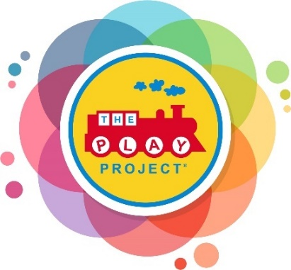
Referral for Play Project Services

Date: Click or tap to enter a date.
Name/Title of Person Completing Referral: Click or tap to enter a date.
Phone #: Click or tap here to enter text. E-mail: Click or tap here to enter text.

Applicant:

Child/Students Name: Click or tap here to enter text.
Address: Click or tap here to enter text., City: Click or tap here to enter text.,
State: Click or tap here to enter text., Zip Code: Click or tap here to enter text.
Date of Birth: Click or tap to enter a date. Sex: Choose an item.

Is the student eligible for County Board services? Choose an item.
Does the student have a diagnosis of Autism or an Autism related diagnosis? Choose an item.
What are the needs and concerns: Click or tap here to enter text.

Parent Contact Information

Parent’s/Guardian Name: Click or tap here to enter text.

(If different from the information above, please complete the following)

Address: Click or tap here to enter text., City: Click or tap here to enter text.,
State: Click or tap here to enter text., Zip Code: Click or tap here to enter text.
Phone #: Click or tap here to enter text. Cell Phone: Click or tap here to enter text.

Signature of Parent/Guardian: Click or tap here to enter text.
Signature of Director of Early Intervention Services: Click or tap here to enter text.
Signature of PLAY Project Consultant: Click or tap here to enter text.

